**COMPUTATIONAL ENGINEERING MECHANICS-1**

END SEM PROJECT

*Submitted By:*

**Nallabothula Vamsi- BL.EN.U4AIE21086**

**Nallamilli S H S P Surya Vardhan Reddy-BL.EN.U4AIE21088**

**Mettu Siddhartha- BL.EN.U4AIE21080**

*In partial fulfillment for the award of the degree*

Of

**BACHELOR OF TECHNOLOGY**

IN

**Computer Science Engineering (Artificial Intelligence)**



AMRITA SCHOOL OF ENGINEERING, BANGALORE

AMRITA VISHWA VIDYAPEETHAM

BANGALORE –560035

FEB 2022

**Faculty: Mr. R. Pramod Date: March 3, 2022**

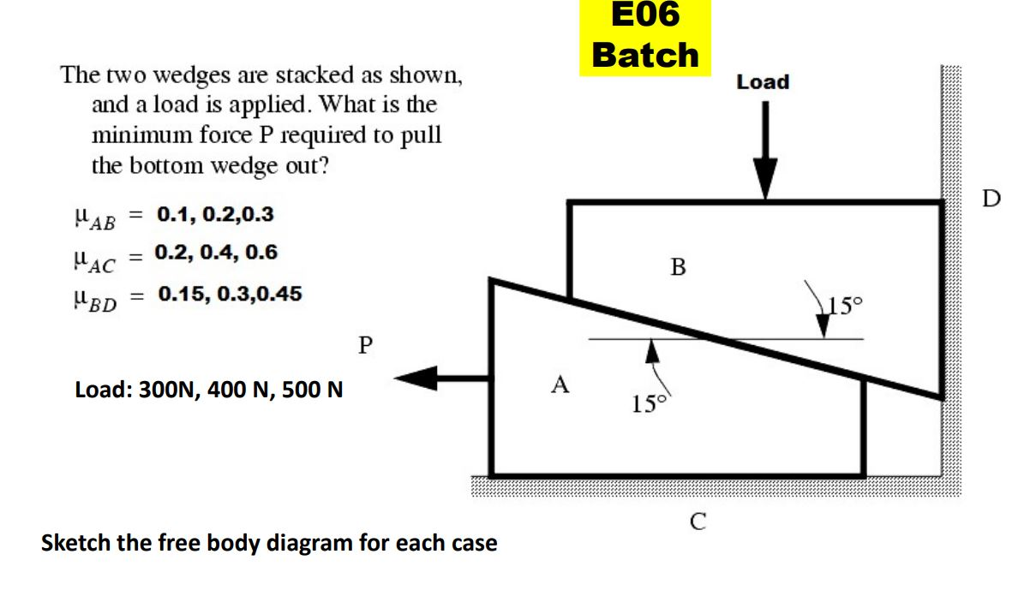

**Solution : -**

These type of problems involve large no of forces and should be attempted using the free body diagrams. So, First step is to draw the FBD for any one wedge.

The Wedge on the top is considered as B When Bottom wedge slips out B will Push against the wall and slide down but A will try to pull it away from the wall​.

**Free Body Diagrams**

FBD of Wedge B

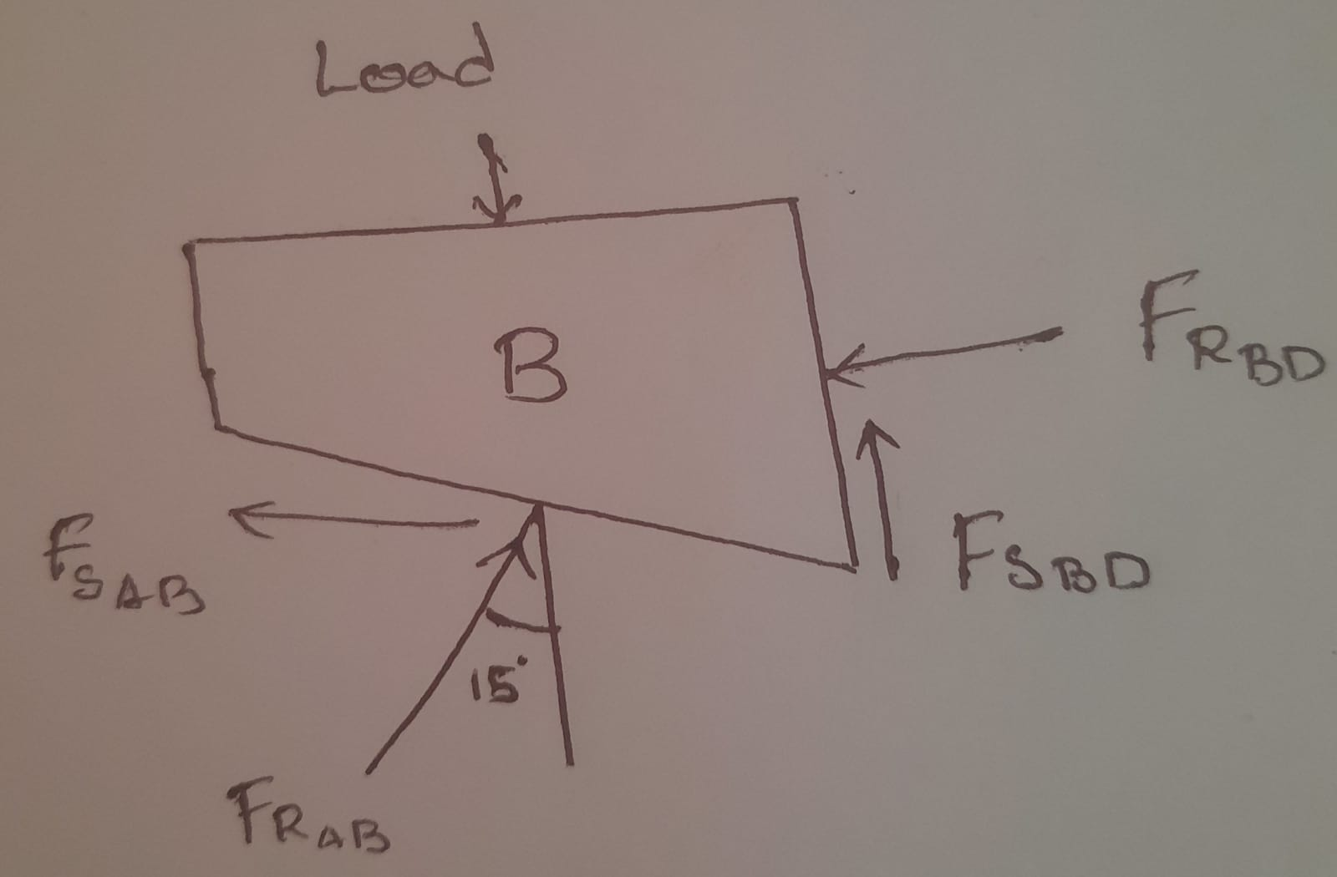

FBD of Wedge A  
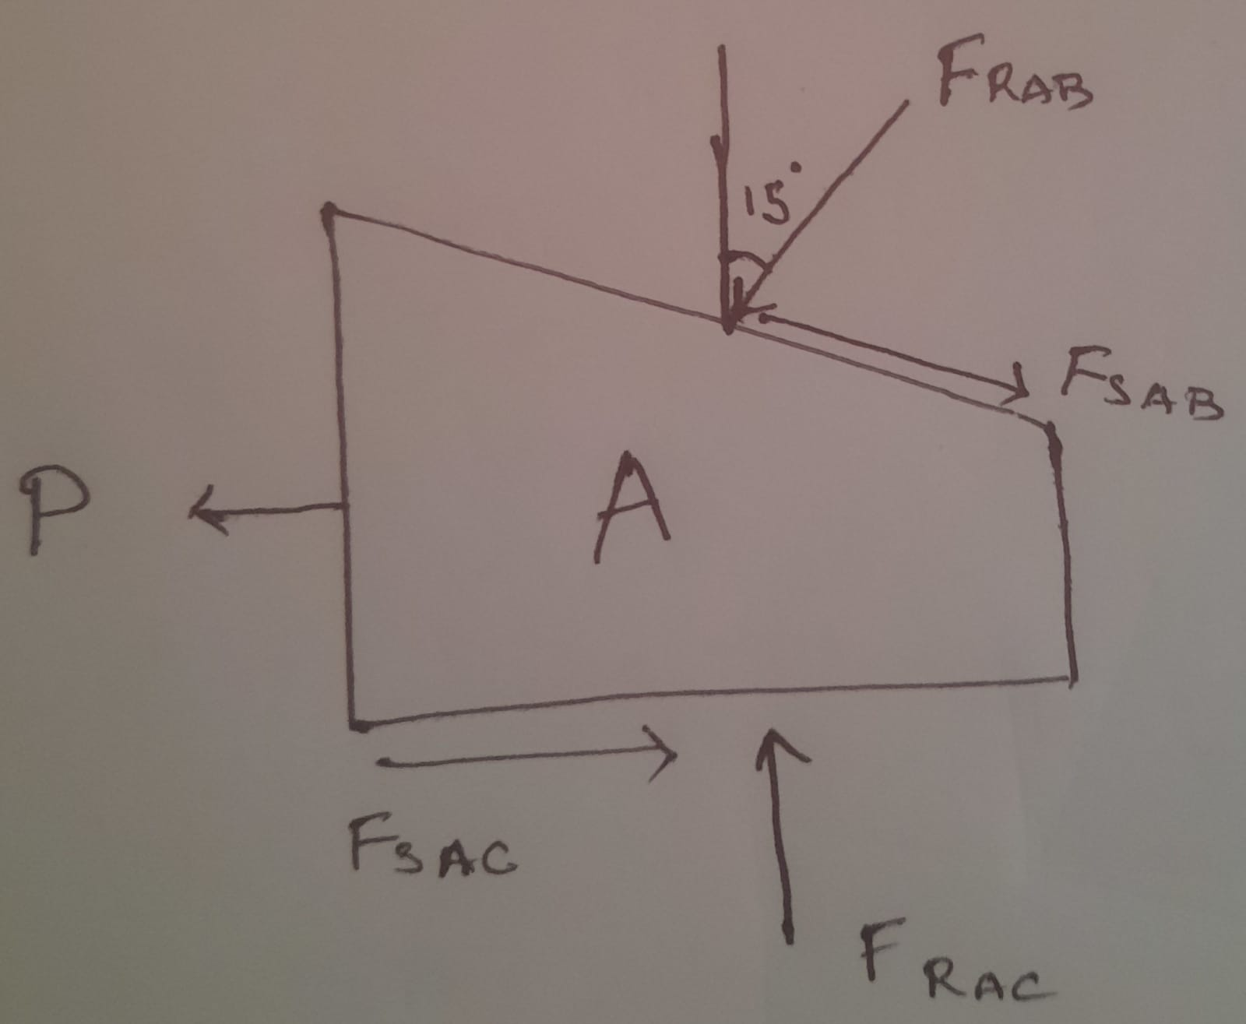

**Case-1**

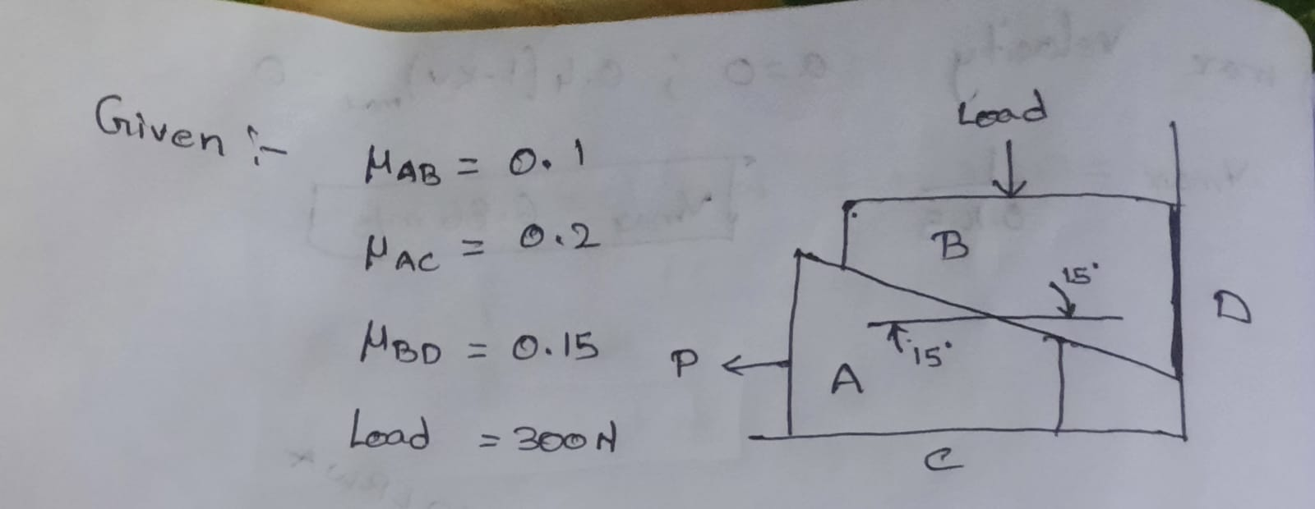

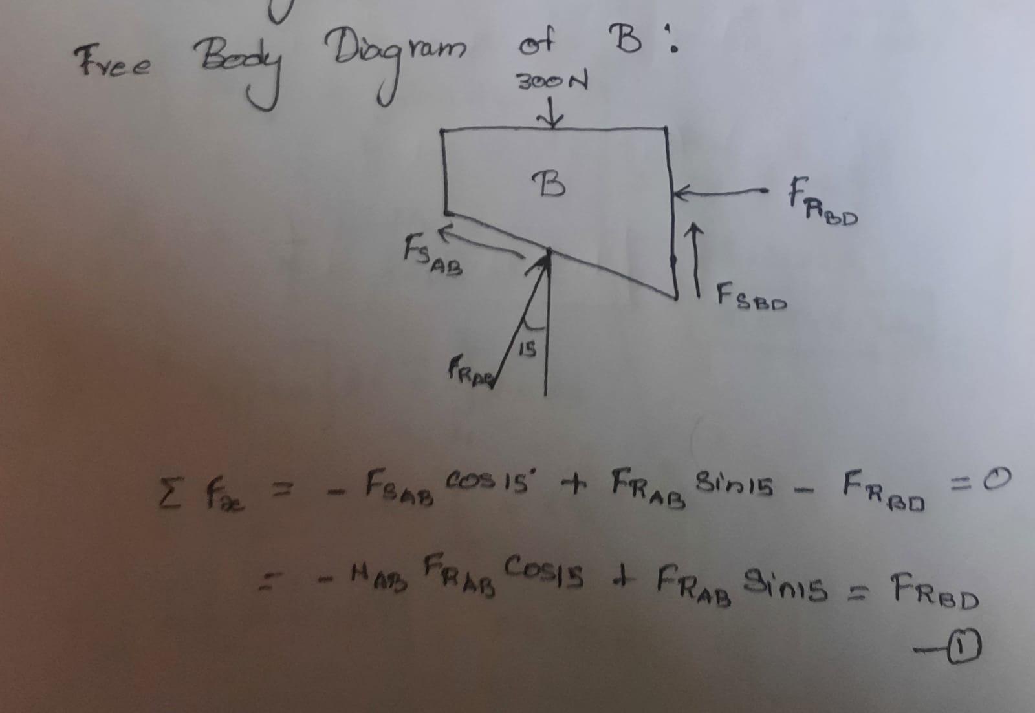

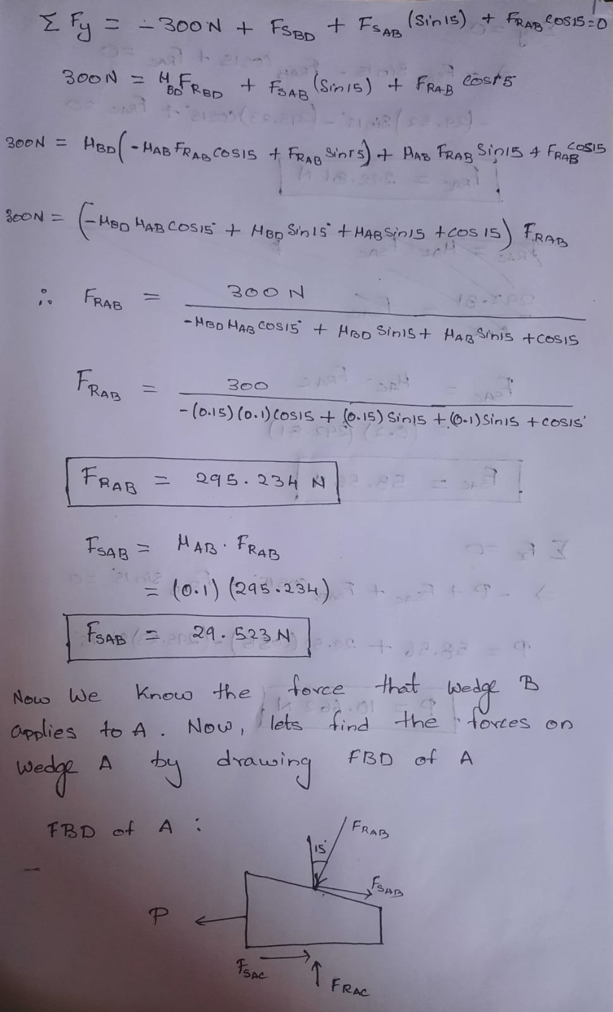

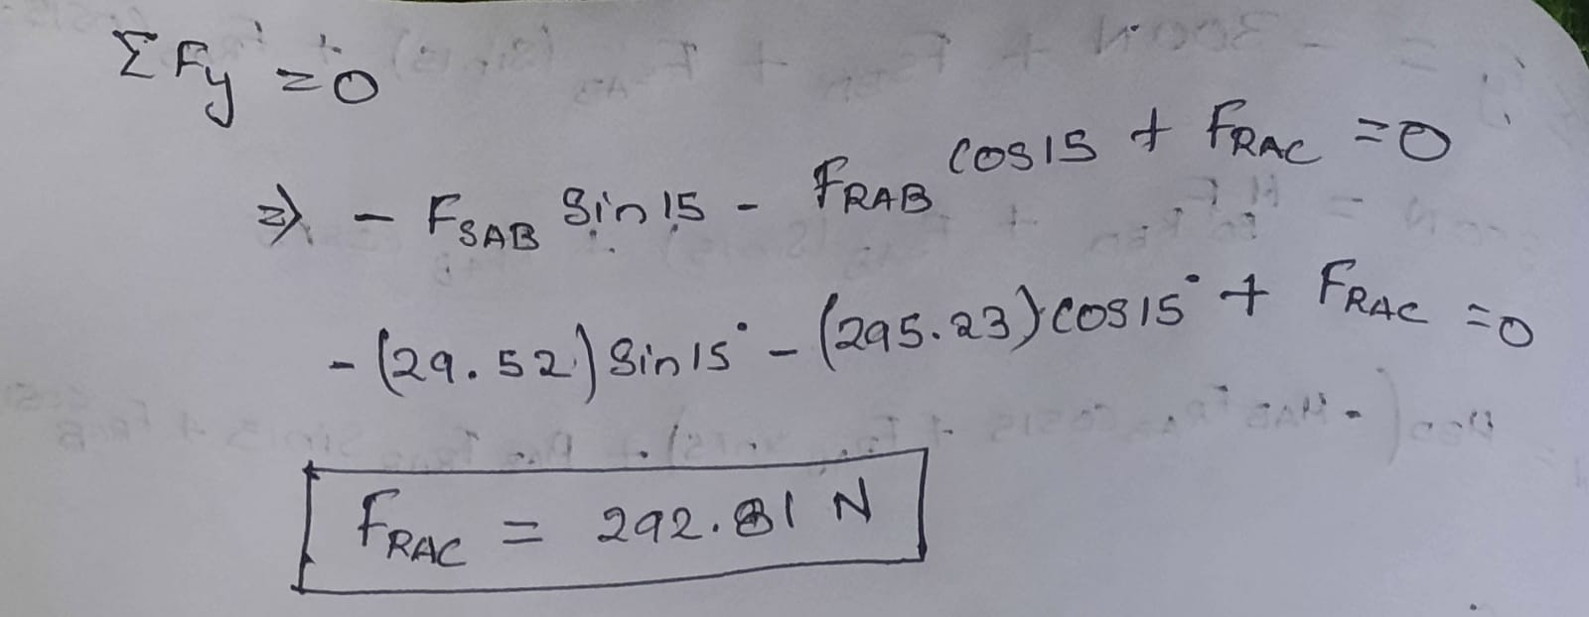

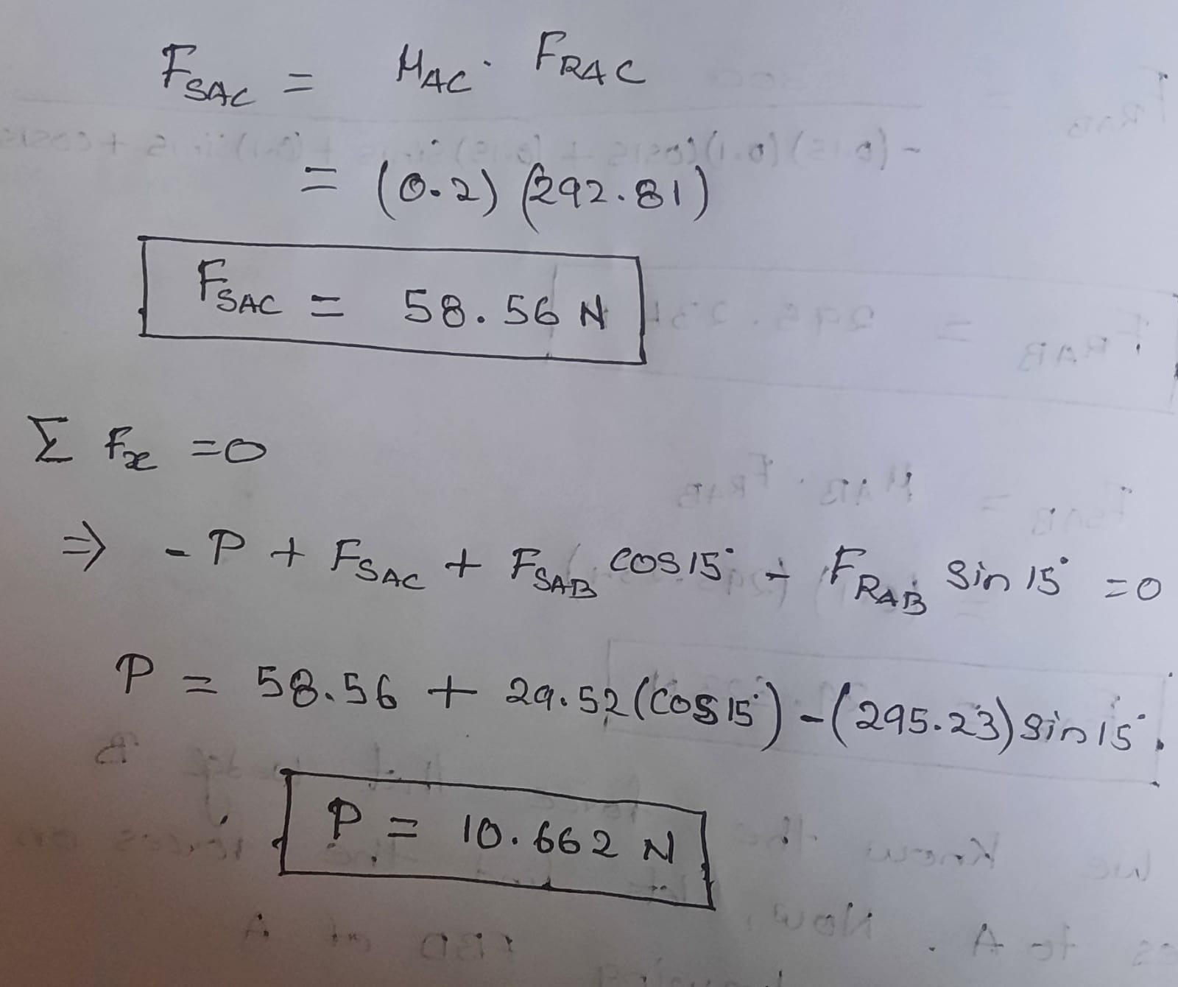

**Case-2**

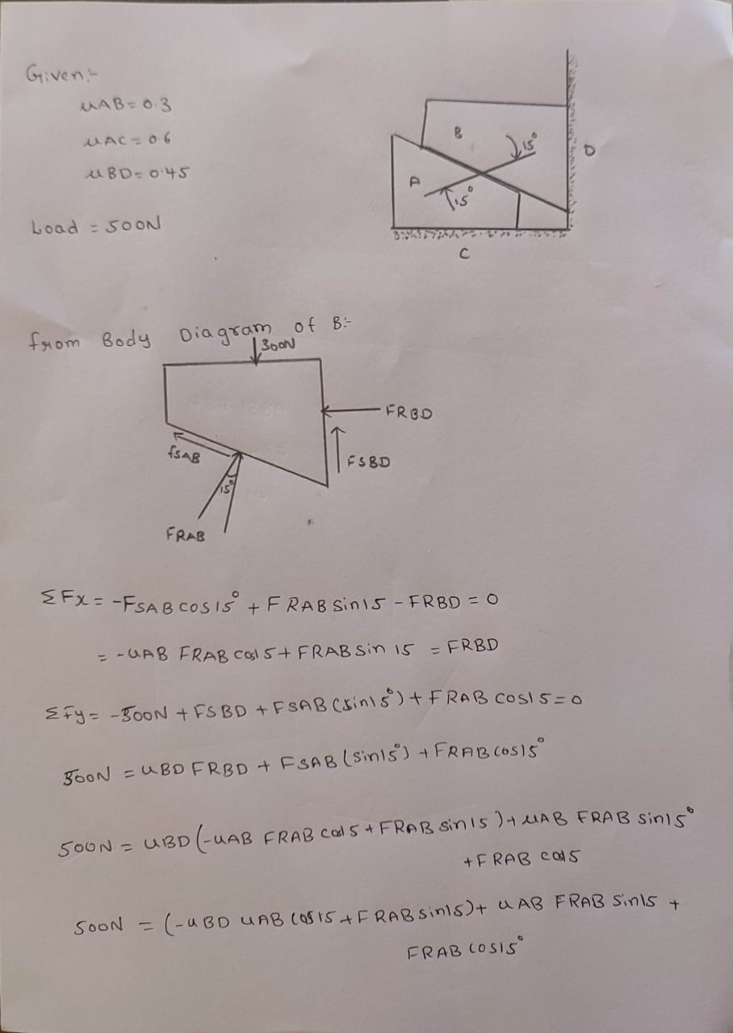

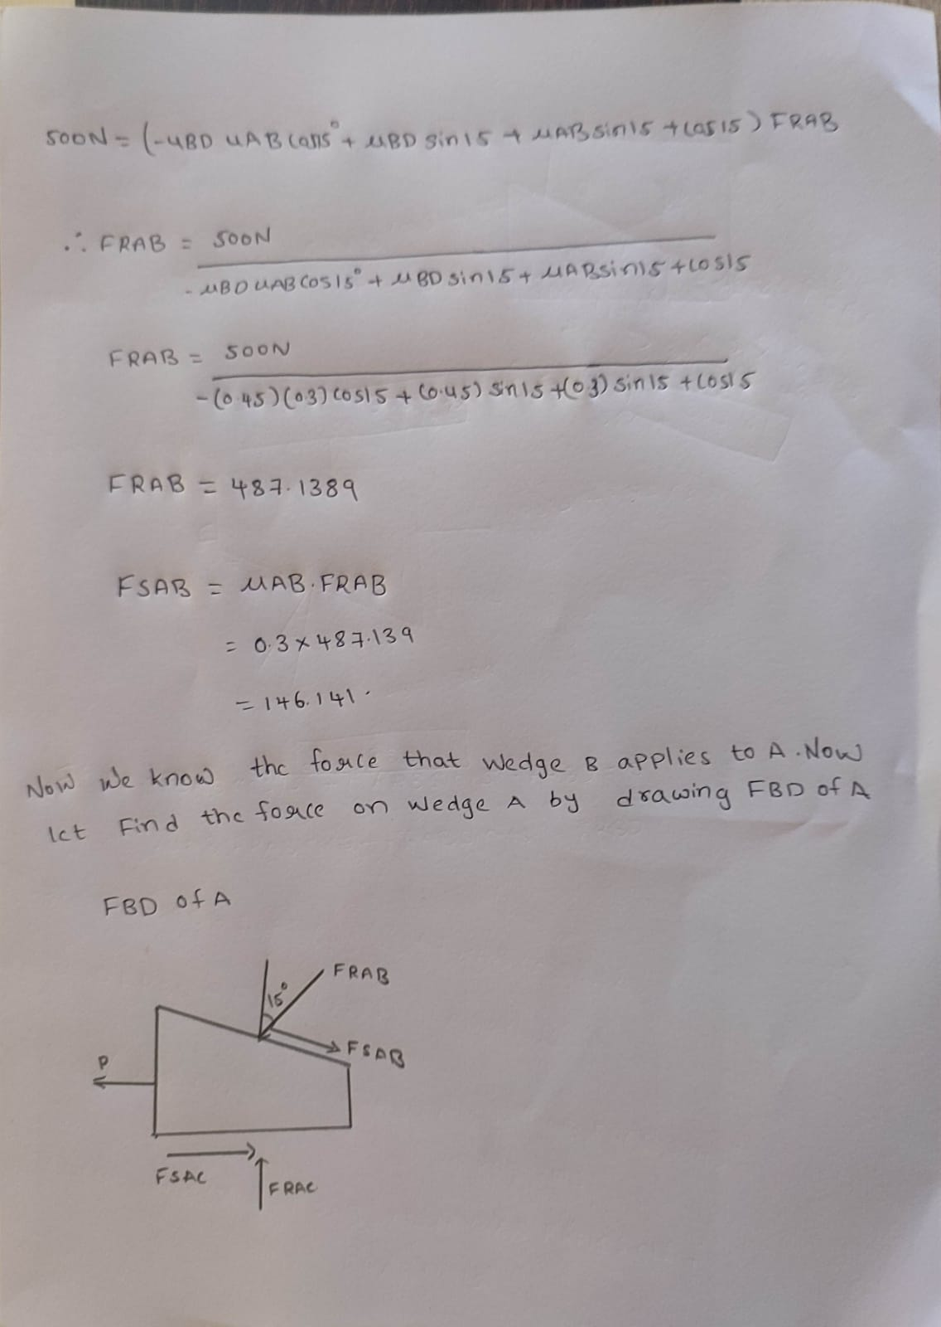

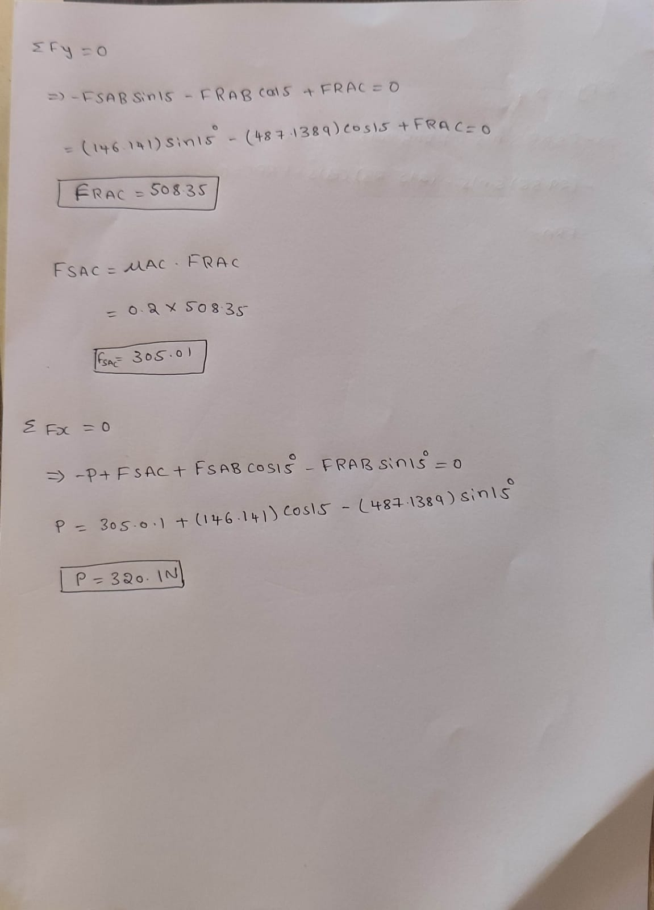

**Case-3**

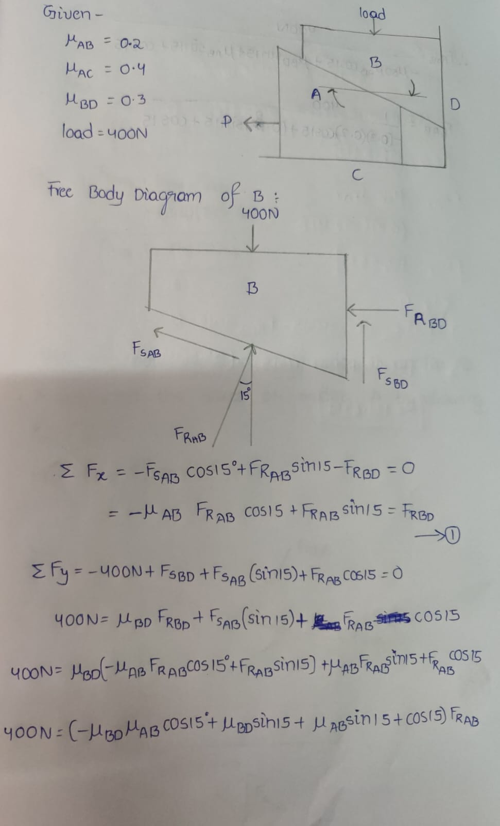

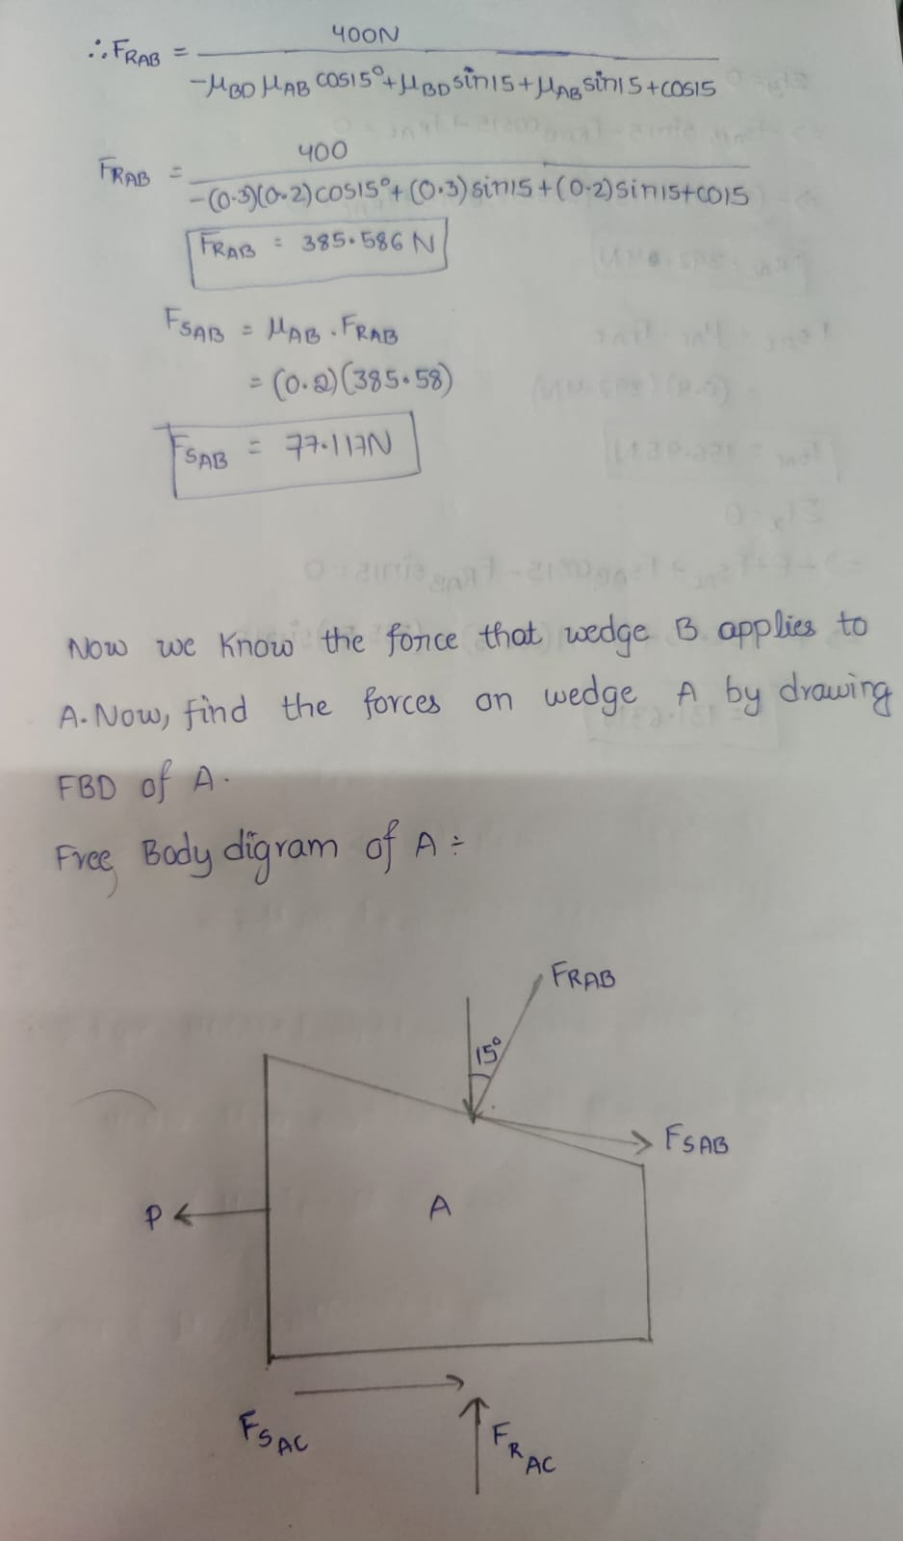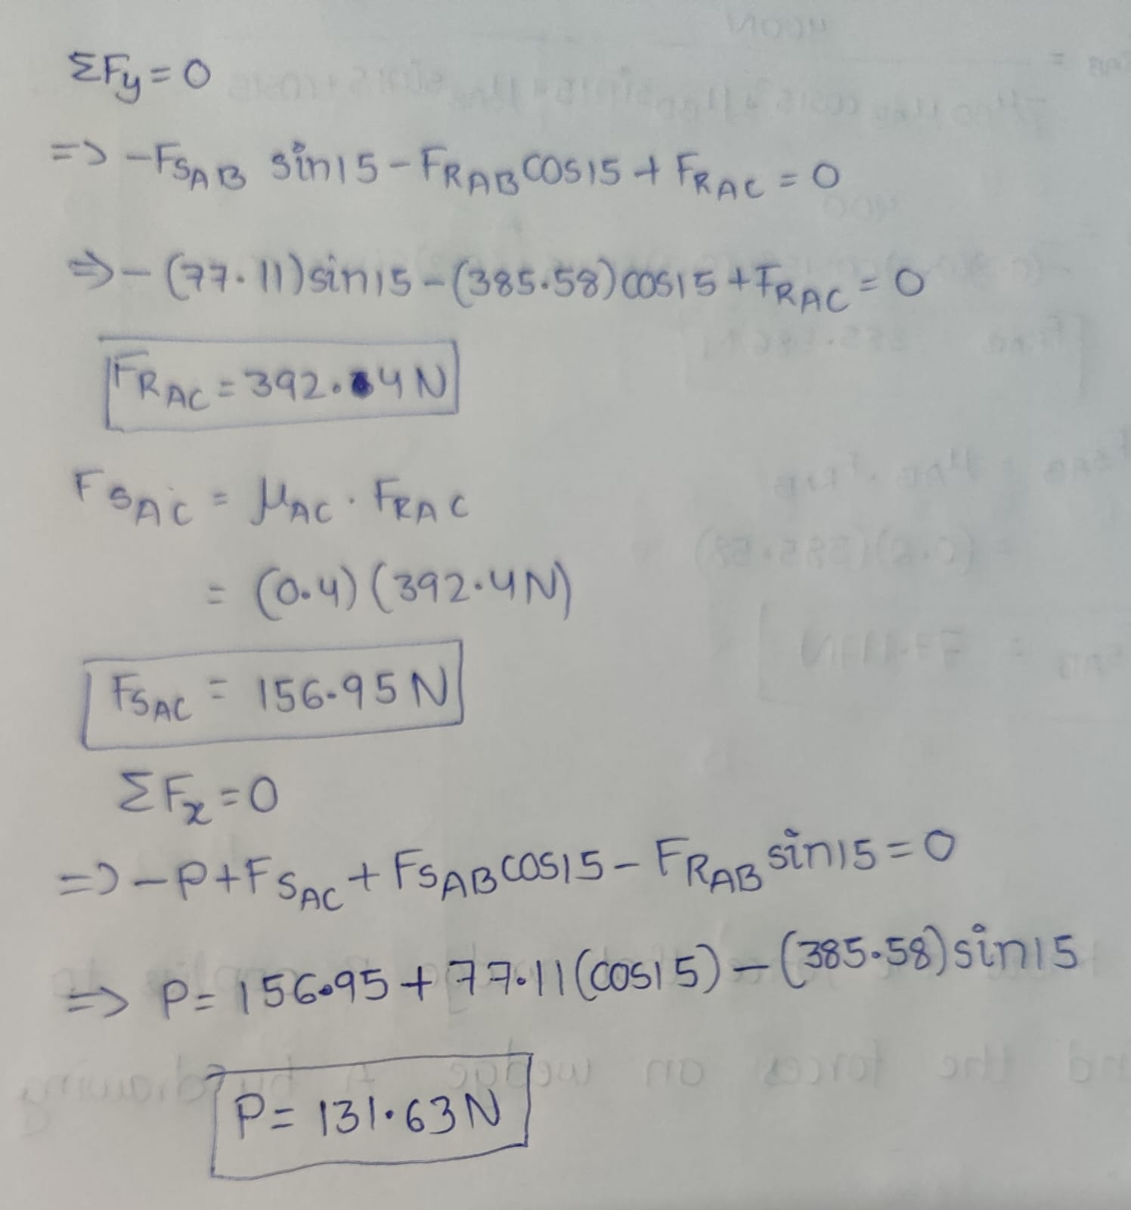

**Result :-**

